IDP workspace guideline

We will enable 4 slave executor in IDP so that workload can be shared among the slave executor.

* below slave executor will be enable for this activity.

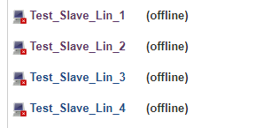

* all the slave nodes has given the label Test_Slave_Lin

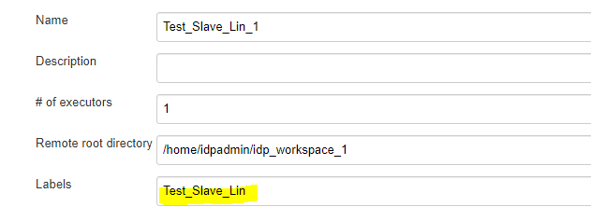

* in IDP while building and deploying the micro service you will select the “label” as Test_Slave_Lin , as per the availability IDP Jenkins will share the load to any of the one slave node among 4 nodes .

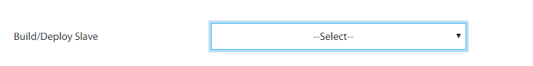

…………………………………………………………………………………………………………………………………………………………………………………………………………………………………………………………………………………………………………

To enable this feature, we need to parameterized the workspace variable in IDP pipeline so that it can dynamically update the workspace in our pipeline.sh and deploy.sh.

Please find the below steps for the same:

* Where ever we have mentioned the IDP-workspace as below:
* cd /home/idpadmin/idp_workspace/workspace/RP_Pipeline_Matching_MS/matching
* please change it to below :

$IDP_WS/matching .

EX:

/home/idpadmin/idp_workspace_1/workspace/FAS_customercreation/customercreation

$IDP_WS/customercreation

* **$IDP_WS = /home/idpadmin/idp_workspace_1/workspace/<IDP-PIPELINE-NAME>**

**EX : $IDP_WS = /home/idpadmin/idp_workspace_1/workspace/FAS_customercreation**

* Similarly for deploy.sh also everywhere you need to change the path .

Ex :

if [ $Deploy_Env == "iecdev" ]

then

sed -i 's/Deploy_Env/iecdev/g' /home/idpadmin/idp_workspace/workspace/RP_Pipeline_Matching_MS/matching/matching.yaml

kubectl apply -f /home/idpadmin/idp_workspace/workspace/RP_Pipeline_Matching_MS/matching/matching.yaml

kubectl delete pod -l test=matchingdeployment -n iecdev

fi

change it to :

if [ $Deploy_Env == "iecdev" ]

then

sed -i 's/Deploy_Env/iecdev/g' **$IDP_WS**/matching/matching.yaml

kubectl apply -f **$IDP_WS**/matching/matching.yaml

kubectl delete pod -l test=matchingdeployment -n iecdev

fi

……………………………………………………………………………………………………………………………………………………………………………………………………………………………………………………………………………………………………………………………………